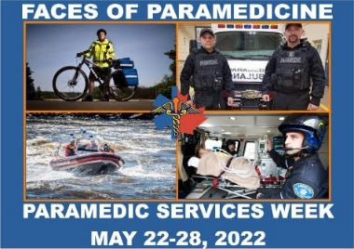
Paramedic Chiefs of Canada
Paramedic Services Week—Faces of Paramedicine Questionnaire

Specialty:
Which “FACE of Paramedicine” are you providing information for?
(communications/dispatch, civilian, community paramedic, air/flight, CBRNE, tactical, marine, public relations, professional development, education, research, technology, logistics, fleet, safety, and/or MANY others)

Education (basic):
What training and/or education is required for this important specialty/role within the profession? Where does one get trained (or educated) for this specialty/role? Are there prerequisites for any component of certification? Are there different levels of certifications? What is the duration of time to achieve each level or program completion?

Education (Advanced):
What specialized training beyond basic training is/may be required for this specialty/role above and/or beyond any medical element, if any? (i.e. physically, academically, mentally, tactically, mechanically, etc.)

Roles and Responsibilities:
Please give a description for the responsibilities of this role? What would a “Day in the Life” of this specialty/ role look like; please give a detailed explanation. (As if you were explaining this to someone who knows very little about this role/speciality; the more detail the better)

Impact:
What kind of contributions and/or impacts does this specialty/role have within the profession, please explain/describe?
(i.e. 911; the entry into the emergency, research; drives change in practice, OH&S; creates safe environments to perform functions, professional development; improves competency, wellness; creates healthy professionals, logistics; tools to perform the job, public relations; promote and educate public, etc.)

Little Known Fact:
What element of this specialty/role would the general public not know about that you would like to share or have highlighted?

Pride and Duty:
What are you most proud of in this important specialty/role within paramedicine? (i.e. share a success story)

The Future:
As a subject matter expert in this area, what advice would you (in this specialty/role) give another to join the TEAM in this important field of expertise within paramedicine?

Pictures/Showcase:
Please provide pictures (several) of individuals in these specialties/roles, within their respective environments where possible with this questionnaire?
(i.e. the tactical medic in gear, marine medic in the water, communications on the radio, procurement in the storage/warehouse, fleet/mechanics with the ambulance, community paramedics with a client (if possible), flight in an aircraft, safety/OH&s in PPE, etc.)

(Assumption will be made of any pictures provided have approval to share/publish)

